**Web Engineering Exercise 7 – Problem 2**

**s1240234 Yuta Nemoto**

Screenshot: List of articles

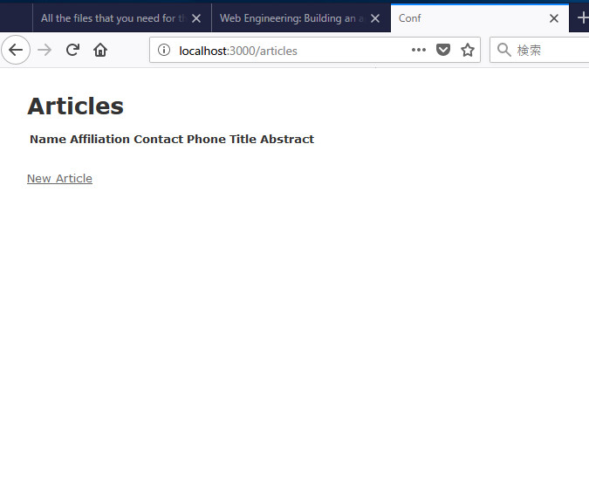

Screenshot: Creating new article

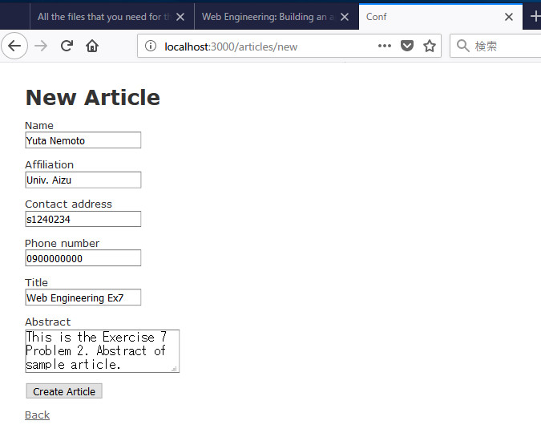

Screenshot: Showing newly created article

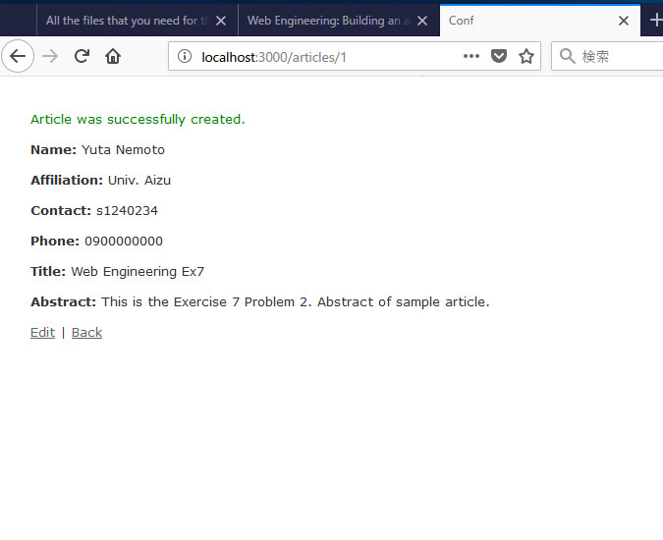

Screenshot: Listing article

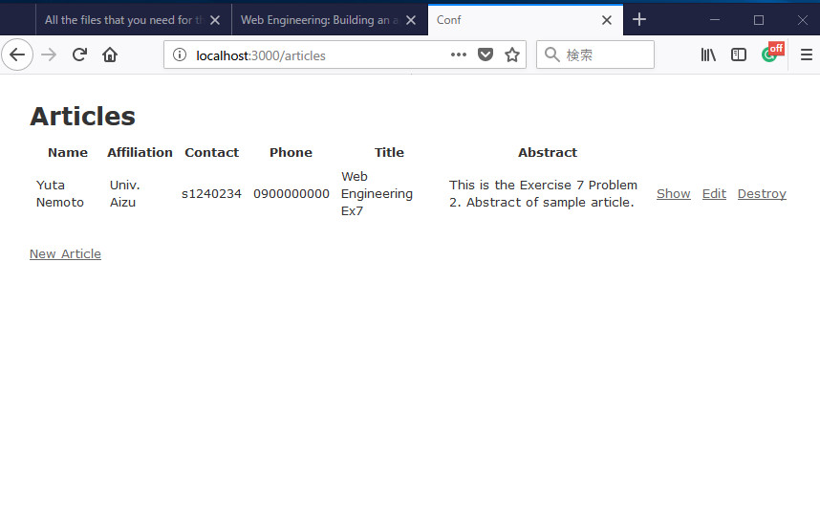

Screenshot: Showing article

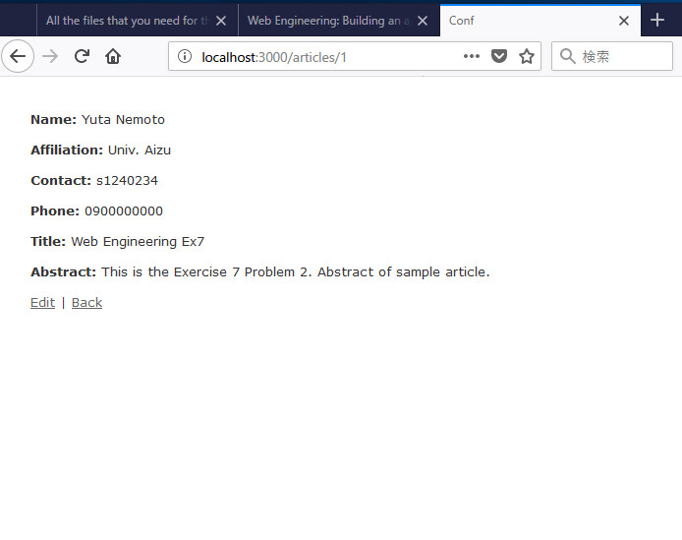

Screenshot: Editing article

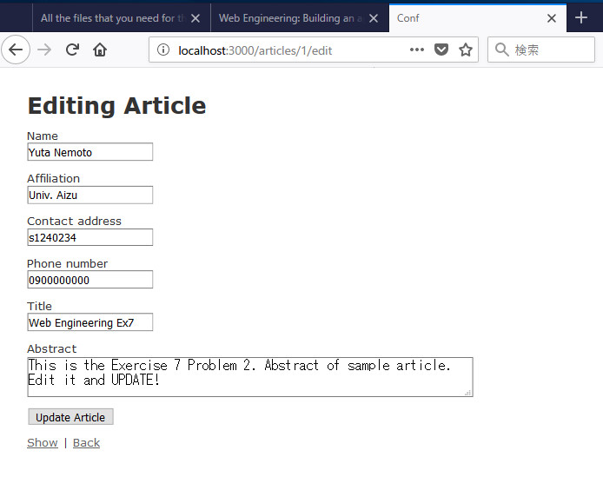

Screenshot: Showing updated article

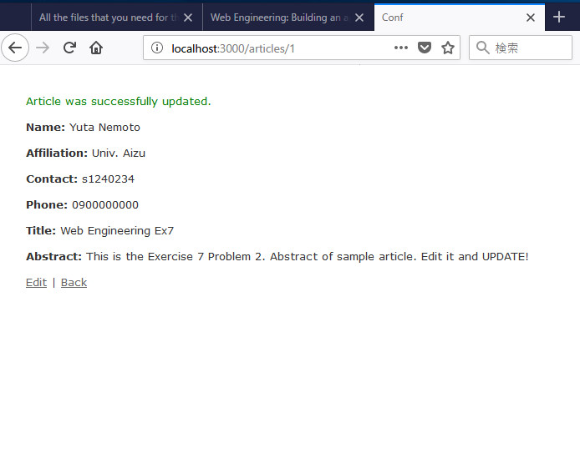

Screenshot: List of article after updating

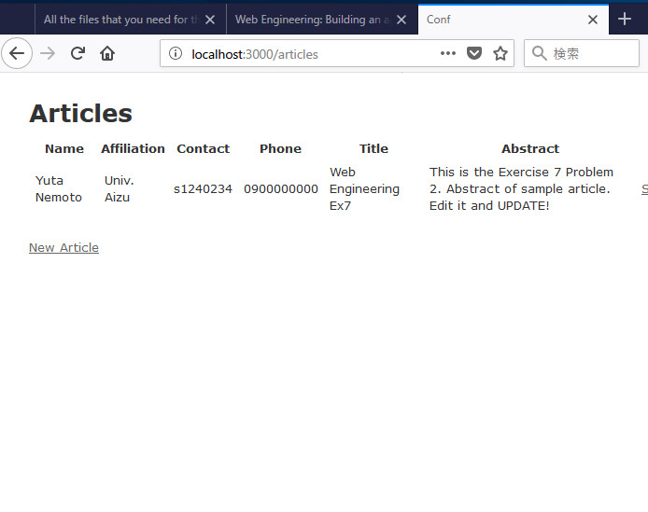

Screenshot: Deleting article

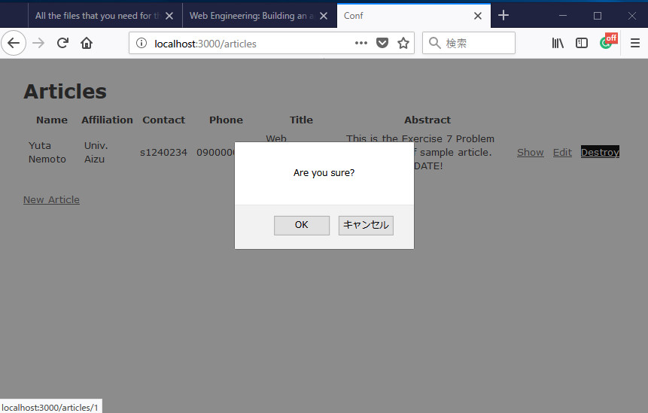

Screenshot: List of article after deleting

